MONTANA SCORECARD STYLE GUIDELINES
Last Updated 9/3/2021
Table of Contents
Introduction 2
Consistent User Experiences 2
Scorecard Website 2
Website Naming Conventions 2
Featured Dashboards and Topics 2
Featured Dashboards 2
Topic Areas 2
Internal and External Dashboards 2
Structure of the Scorecard Tableau Site 2
Publishing Scorecard Dashboards 3
Dashboard Design Standards and Best Practices 3
Dashboard Standards 3
Main View 3
Information Icon 3
Dashboard Filters 5
Dashboard Best Practices 5
Workbook and Dashboard Names 5
Number of Visualizations 5
Colors 5
Chart Types 5
Scroll Bars 6
Mobile Layouts 6
Tooltips 6
Additional Resources 6
Adding Dashboards to the Scorecard Website 6

Introduction
The following style guidelines have been developed to promote consistency for the Montana Scorecard. This style guide is to help achieve consistent user experiences and effective visualizations. These guidelines should be used for all dashboards that will be used on the Scorecard, but the instructions are specific to Tableau.
Please note this is a living document and will change over time.

Consistent User Experiences
There are numerous different ways of doing things in Tableau. But, for the people using your dashboards, figuring out how to get the information they want should be quick, easy, and intuitive. The aim of this guide is to help you design dashboards that embrace this.

Scorecard Website

Website Naming Conventions
The Scorecard website will follow a naming convention for all pages within the site. This naming convention will be followed by all agencies, divisions, and bureaus (when applicable). The format is:
https://[Agency Acronym].scorecard.mt.gov/[Division]/[Bureau]
(e.g., https://doa.scorecard.mt.gov/sitsd/atsb).

Featured Dashboards and Topics
Each page of the Scorecard has two sections, Featured Dashboards and Topics.

Featured Dashboards
This section includes dashboards that provide highly valuable, summary level data and are frequently used.

Topic Areas
This section includes lists of available dashboards within a certain topic area (e.g., website analytics). These topics may include dashboards from other agencies or divisions and can be shared between pages within the site.

Internal and External Dashboards
SITSD hosts two Tableau Server clusters, one internal to the state network (https://tableau.mt.gov), and one external for public facing dashboards (https://tableauext.mt.gov). When developing dashboards, users must be aware of which cluster the dashboard needs to be published to based on where it will be embedded.

Structure of the Scorecard Tableau Site
The Scorecard site on Tableau Server (both the internal and external cluster) will mirror the structure of the website. Within the site, there are project folders for each agency, and sub-projects within each agency project for the individual divisions and bureaus (if applicable).

Publishing Scorecard Dashboards
When publishing dashboards that will be included on the Scorecard website, the dashboard needs to be published to the Scorecard site on the appropriate Tableau Server cluster (internal or external), within the appropriate agency and division project folders. This will ensure it is easy to determine where a dashboard is supposed to reside on the website.

Dashboard Design Standards and Best Practices

Dashboard Standards
For the Scorecard, the following items will be required for all Dashboards.

Main View
The main view of a dashboard should be summary level data in which users can get the high-level information they need. From there, users can have dashboards drill down further into the data for more details as needed. The ability to guide a user through a dashboard and allow them the option of viewing greater detail will allow them to gain insights quicker and act on what the data is telling them.

Information Icon
All dashboards need to include an information icon, located in the upper, right of the dashboard, and will include the following information:
- Data Source(s) used within the dashboard
- Last Update Date/Time of the data being used in the dashboard
- Maintained By:
  - This should be a group within a user’s agency, not an individual person.
Examples:
Tooltip Information Example:
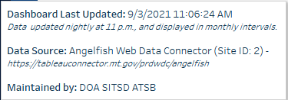
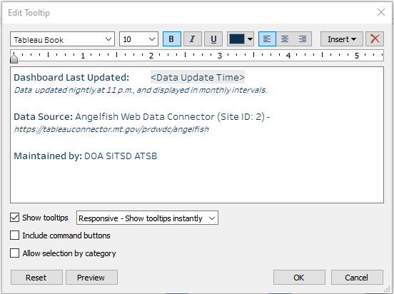

Information Icon Placement Example:
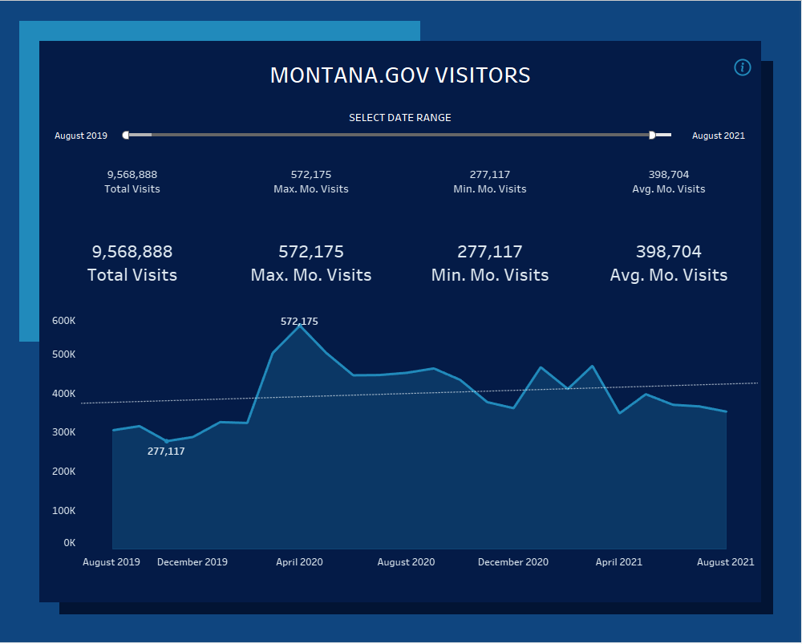

Dashboard Filters
- If filters are being used on the dashboard, all should be placed directly below the header of the dashboard.
  - If a Date filter is being used, it should be placed on the left side of the dashboard.
  - If the ability to search is needed, a freeform text search should be used, and placed on the right. Information on how to create this can be found on https://howto.mt.gov/Tableau.

Dashboard Best Practices

Workbook and Dashboard Names
When publishing workbooks and dashboards to Tableau Server, it is a good rule of thumb to name workbooks, dashboards, and views appropriately. The workbook name should be descriptive of the full workbook contents. The dashboard name should be descriptive of the individual dashboard. The view name should be descriptive of the individual view. In all cases, the names should not be published with the default ‘Dashboard,’ or ‘Sheet’ names, or the organization’s name.

Number of Visualizations
A dashboard should have between 3 to 6 graphs/charts to ensure the content is interesting, but the space is clean and uncluttered. The primary focus of the dashboard (the most important chart) should be placed as close to the top and left as possible as this is generally where eyes focus first.

Colors
Colors should have a clear purpose. As a simple rule of thumb, color should be used to draw the eye to data points within the visualization. Your data visualizations should be able to work in grey scale.
If you are using color to distinguish between elements in a dashboard, be sure the logic follows through consistently. For example, be sure that a single color does not have multiple meanings within the same dashboard or series of dashboards.
If Legends are needed to signify the meaning of colors, ensure they are placed appropriately, either at the bottom of a dashboard, or on the corresponding view within the dashboard.

Chart Types
When selecting a chart type to display your data, it should depend on the question you’re trying to answer or a specific insight you are trying to communicate. Don’t just duplicate your Excel worksheet in Tableau. Visualizations should be visual, not a bunch of numbers on a screen. Whenever possible, use the following guidelines:
- Bar charts to compare numbers
- Stacked bars for categorical comparisons
- Line charts to depict trends over time
- Scatter plots to easily see outliers
- Maps to depict data geographically
Inevitably, you will need to use tables in your displays, and there is nothing wrong with that. However, we encourage you to use a simple, clean layout and ensure you add interactive elements to a table, so it connects to the rest of the dashboard. If you’re displaying a lot of data, consider using a more visual approach first, and allow users to drill down into simplified tables as needed.

Scroll Bars
Avoid having scroll bars in your visualization. In most cases, your visualizations are going to be viewed in a browser, which already has a scroll bar. Having more than one set of scrollbars in a page will lead to un-even scrolling and a poor user experience. In most cases, you can use the ‘fit view’ option within your dashboard to avoid this.

Mobile Layouts
Dashboards should be developed in a way where they are responsive to screen sizes. To do this, users will need to add Desktop, Tablet and Phone layouts to their dashboards. This is done through Tableau Desktop, within the dashboard editing view.

Tooltips
Your tooltips should help provide further information about the data being displayed in the dashboard. Typically, the default information contained in a tooltip should not be used as it won’t make sense to the average user.

Additional Resources
- Scorecard Dashboard Templates
  - To use these dashboard templates, download the workbook from Tableau Server and follow the instructions from the ‘How to Use’ tab.
  - Note: If using these prebuilt templates, you do not need to keep the colors the same as what they are in the workbook. They are just example templates.
- Viz Vocabulary for Tableau
- Visualization Universe
- Data Visualization Catalog

Adding Dashboards to the Scorecard Website
To add dashboards to the Scorecard website, please submit a Tableau Service Request through the Service Desk online. Agencies should provide the following:
- Title of the Dashboard
  - The title should help users identify the information they are looking at and use a specific keyword that users would typically search for.
  - It should not include agency or program acronyms.
- Short Description
  - This should be no more than two lines describing the contents of the dashboard.
- Thumbnail Image of the Dashboard
  - If this isn’t provided, SITSD will generate one based off the provided link.
- Link to the Dashboard
  - To get the appropriate link from Tableau Server, navigate to the workbook and open the main view that is being linked to. Within the view, click on the ‘Share’ button, and copy the link from the dialog box.
    - Note: this link is not the same as the link displayed in the browser address bar.

