Guide to Enabling Content Approval in DNN
This pictorial guide shows how to set up a two-step DNN content workflow where members of one security role edit content in an HTML Pro module and those of a second role publish it.
What you need:
- Two DNN security roles (great if they are linked up with Active Directory groups of identical name and Universal scope). In this example
- Edit Content rights on the HTML Pro module (all DNN workflows are on modules – in the settings for a module you can extend workflow settings to all pages or a whole portal but really what you are affecting is the setting on HTML modules. If Edit Content is set on the modules, the containing pages can even have only View rights (see next two screenshots)
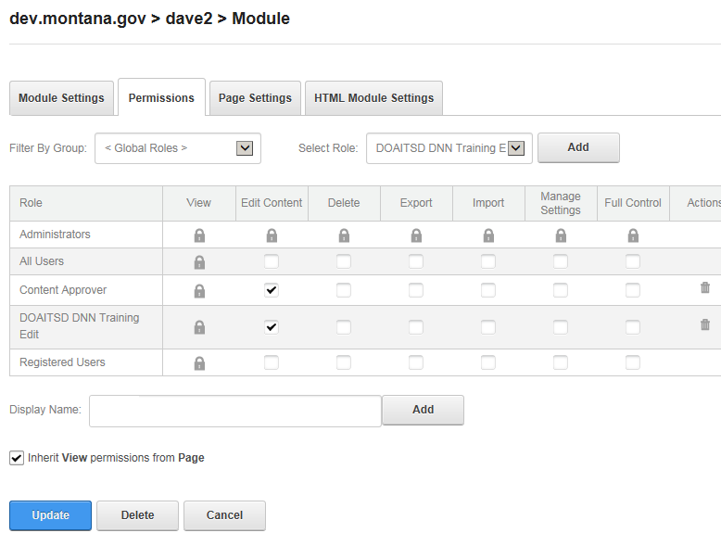
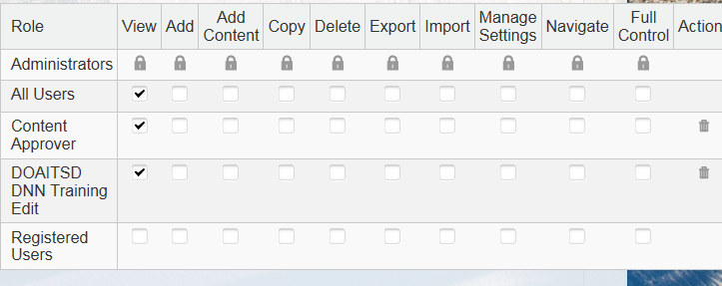

Setting up a workflow
There is a default Content Approval workflow in DNN along with the other Save Draft and Direct Publish. If your site only has one group of approvers you can modify and use the existing workflow; if not you will need to create a workflow for each editor/approval team. For a new one. From an HTML Pro module -> Settings icon (the gear) -> Settings -> HTML Module tab go to the Workflow section and click Manage Workflows and then Add New Workflow. Give a name and description and hit Update

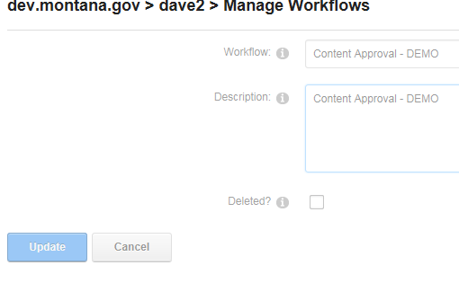

Then in the section below where the workflow states are listed (Save and Publish states are created by default) Click Add New State
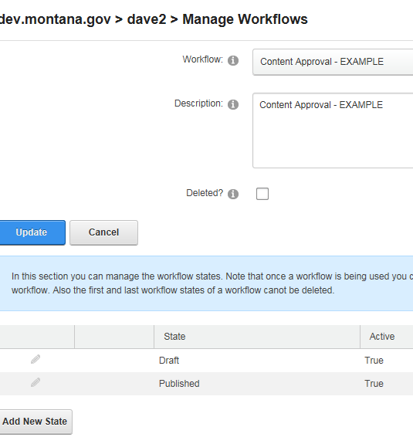
Give it a descriptive name and associate the security role of the reviewers with it. Click the Notify box to set up notification to reviewers when something is sent to them and to editors when their edit is rejected.
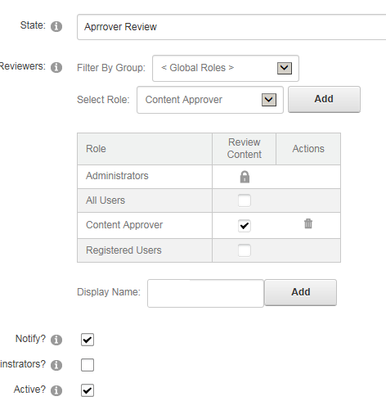
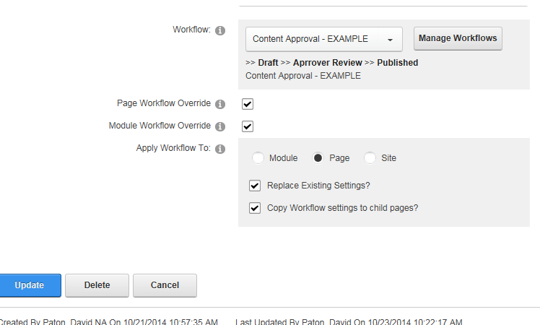
That’s it. As editors do work, to start a review process they Publish normally via the DNN edit pencil or Publish Changes checkbox next to the editor Save button. Add a comment on the edit:
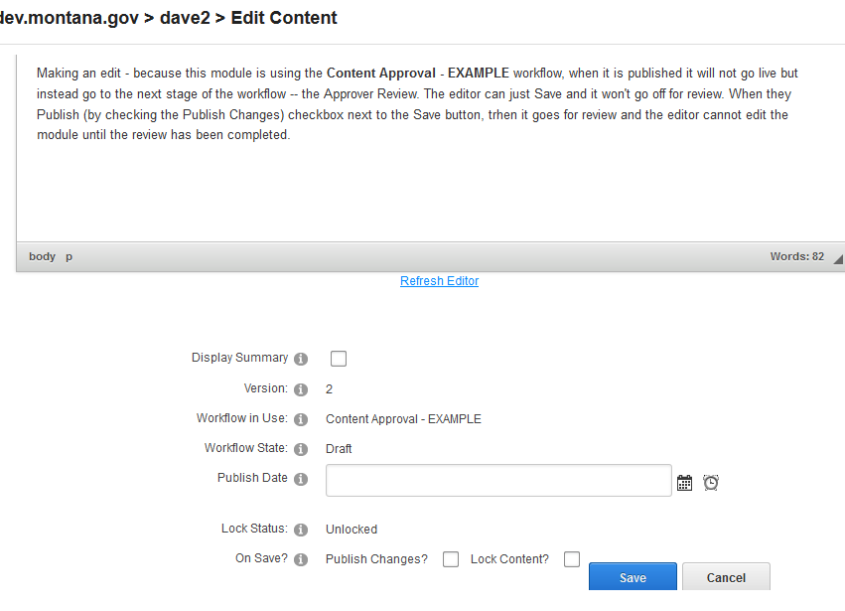

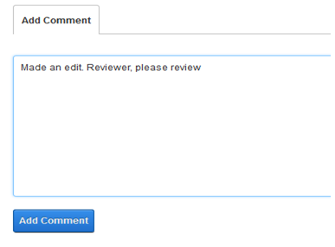
The reviewers get an email letting them know there is something to review
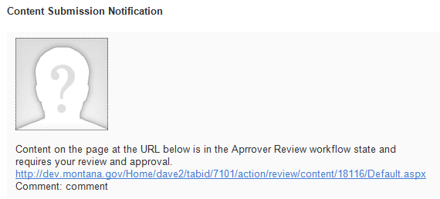
They visit the page and can Approve or Reject, adding their own optional comment
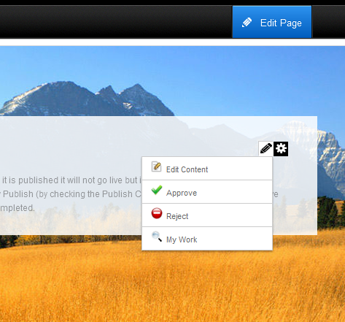
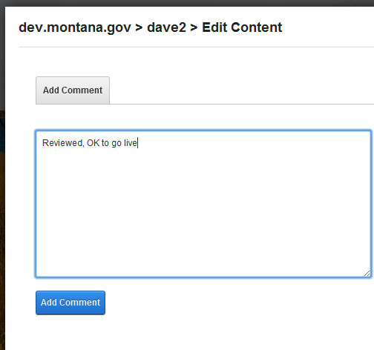

The My Work option under Edit Content lists all content ready for review
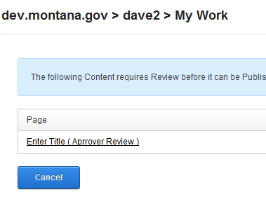
The reviewer can Reject an edit, providing a comment which is probably more important to provide in this scenario
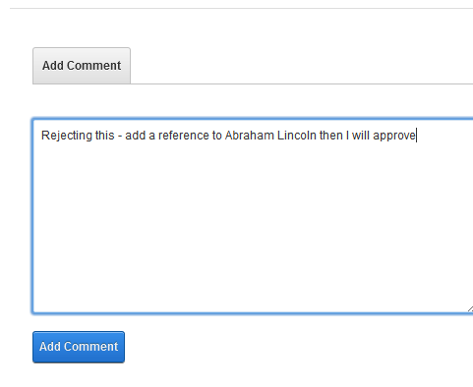
The members of the editors security role get this email
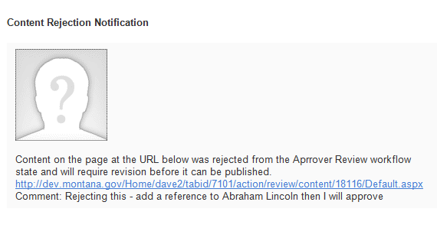
And can edit the page again – note that after Publishing in an approval workflow the editor is locked out from the content until the reviewer takes an action (Approve or Reject)
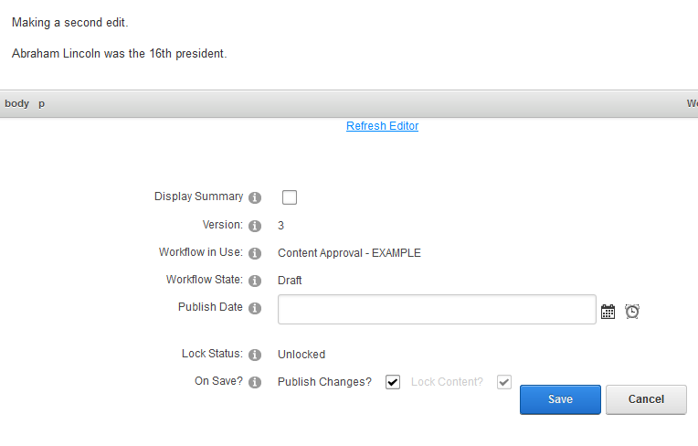

Questions to the DNN admins at webwork@mt.gov

